79.11.28a
From J. Ednie Brown
RB MSS M59, Library, Royal Botanic Gardens Melbourne.

Forest Board Office, Adelaide,
28/11/79
Dear Sir Ferdinand,
I now beg to send you all the information I can gather regarding E. Behriana.
I find the species in two distinct forms in the Flinders Range (Wirrabara) these are:—
First — In the form of a small tree or tall shrub, from 15 to 20 ft in height growing in dense clusters; bark deciduous decorticating in thin strips; found on light sandy clay loam soil: subsoil deep and of clay. The old bark is somewhat persistent on trunk: timber too small to be of any use, is hard, but light. The enclosed sketch 2o. refers to this variety.
Second. A tree of about 40 to 50 ft. in height (perhaps less) growing on a good sandy loam in gorges in Flinders Range. Bark slightly furrowed and persistent on trunk, deciduous on young wood. Timber of good quality, but the trees subject to heart rot at mature age.
The enclosed sketches of the smaller variety of E. Behriana are by Mr. J. W. Love one of my assistants.
I am this morning in receipt of your favor of 21st inst. re. E. goniocalyx. Would you like some further information regarding this tree?
I note what you say as to sending you better defined specimens. I will try to do so in future, but it is difficult to visit the trees just at that particular time when the specimens are in the state you describe.
Mr Homeyer (an acquaintance of yours I believe) is now acting as one of my assistants (Forest Ranger) of Woolundunga Forest Reserve, Quorn.
I am glad to hear that Mr McEwin is assisting you by sending specimens of Eucalyptus.
I am
Dear Sir Ferdinand,
Yours very truly
J. E. Brown

Baron F. Von Mueller K.C.M.G.
Gov. Botanist
Melbourne

Eucalyptus Behriana
Eucalyptus goniocalyx

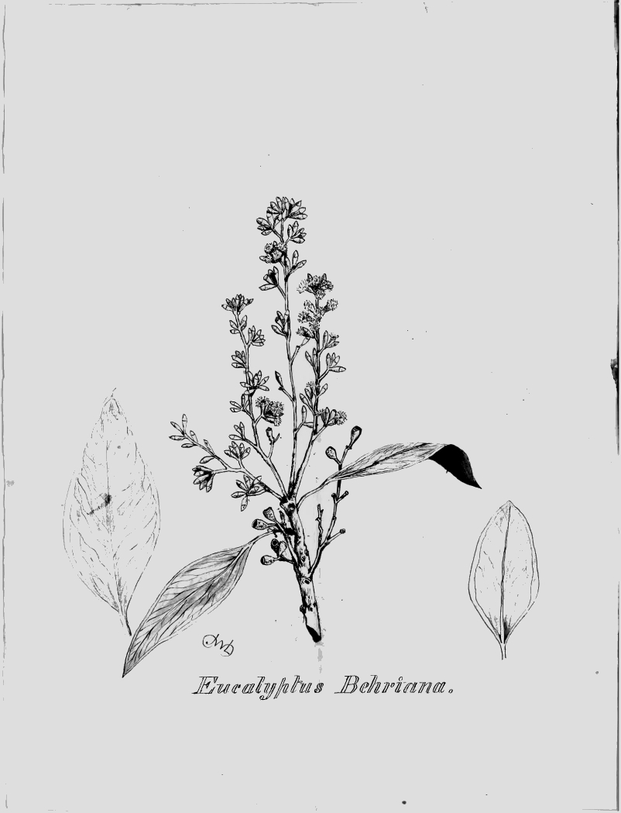

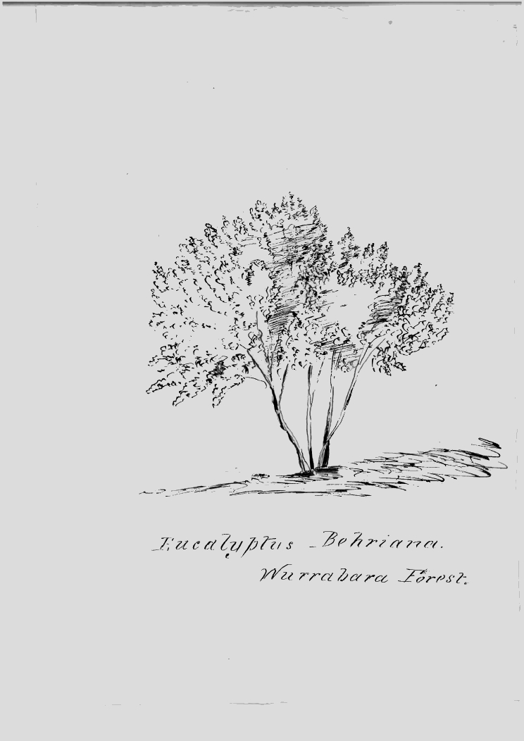

MS found with a specimen of Eucalyptus behriana (MEL 1606642-3). MS annotation by M: 'Answ 2/12/79. F.v.M.' Letter not found. For a copy of this letter see GRG 16/3/1 Conservator of Forests letter press copy book, pp. 264-5, Woods and Forests Department, State Records of SA, Adelaide.
See J. E. Brown to M, 28 October 1879; J. E. Brown to M, 11 November 1879 (in this edition as 79-11-11b); and J. E. Brown to M, 12 November 1879.
SA.
Marginal annotation by M: 'E. Behriana'.
Marginal annotation by M: 'E. hemiphloia (E. albens)'.
The letter is accompanied by two ink sketches. One is of the tree and is labelled 'Eucalyptus Behriana. Wurrabara [sic] Forest': 79-11-28a_image01.jpg The other, which has been initialled by Love, shows details of the leaves and flowers on a branchlet, labelled 'Eucalyptus Behriana': 79-11-28a_image02.jpg Subsequent herbarium annotations have been removed from both images. The SA Public Service List, 1880 (SA Parliamentary papers, 1880, Paper no. 2) lists a J. H. Love as a Ranger on the staff of the Forest Board. However, Brown clearly gives the second initial as 'W.', as does Love himself in initialling the sketch of the leaves and flowers.
Letter not found.
SA.

